How does a team member get his/her Form W-2 online?
If a team member needs to have his/her password reset, contact Payroll at 806-791-0220.

- Sign in to Doculivery at http://www.doculivery.com/unitedfamilypayroll
- Select the Tax Forms tab
- Click the link: Click here to opt-in for electronic Tax Forms!
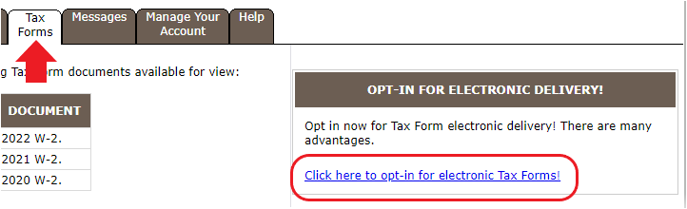
- Complete the required fields and save opt-in.
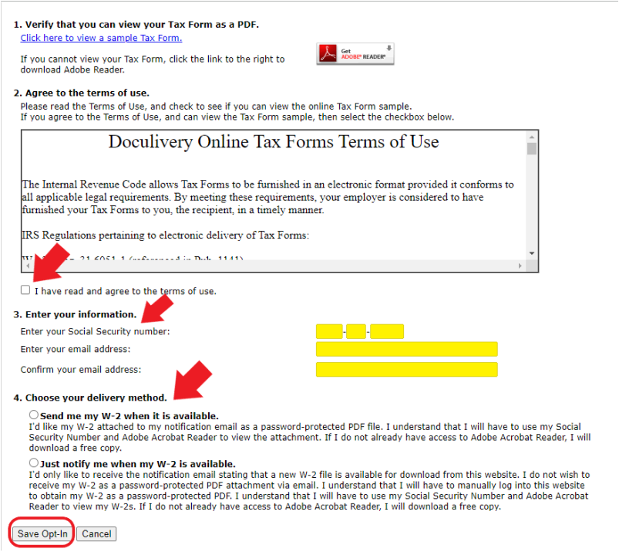
- Select Ok on pop up.
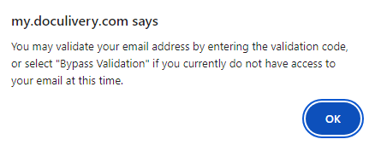
- Complete email validation or bypass validation.
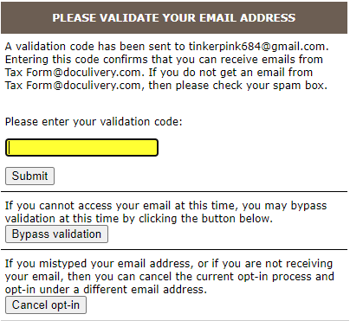
- Once validated you will receive a pop up advising you are opted in.
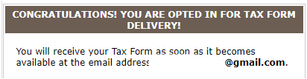
- Once all steps have been completed, the W-2 will be available online immediately.

